Profile of the

Southern Illinois Drug 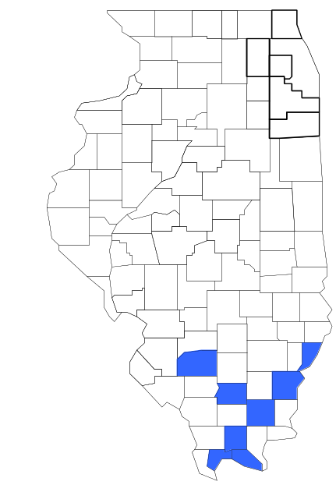Task Force

Prepared by

The Research and Analysis Unit of the
Illinois Criminal Justice Information Authority

George H. Ryan, Governor
Peter B. Bensinger, Chairman
Candice M. Kane, Executive Director

March 2001



ILLINOIS
CRIMINAL JUSTICE
INFORMATION AUTHORITY

This project was supported by Grant # 99-DB-BX-0017, awarded to the Illinois Criminal Justice Information Authority by the Bureau of Justice Assistance, Office of Justice Programs, U.S. Department of Justice. The Assistant Attorney General, Office of Justice Programs, coordinates the activities of the following programs, offices and bureaus: Bureau of Justice Assistance, Bureau of Justice Statistics, National Institute of Justice, Office of Juvenile Justice and Delinquency Prevention, and the Office for Victims of Crime. Points of view or opinions contained within this document are those of the authors and do not necessarily represent the official position or policies of the U.S. Department of Justice.

Illinois Criminal Justice Information Authority
120 S. Riverside Plaza, Suite 1016
Chicago, Illinois 60606-3997
Telephone (312) 793-8550
Telefax (312) 793-8422
TDD: (312) 793-4170
World Wide Website http://www.icjia.state.il.us
ACKNOWLEDGMENTS

A number of organizations and individuals put a great deal of effort into the development of this document. The Authority’s Research and Analysis Unit is very grateful for the assistance provided by the following organizations:

Administrative Office of the Illinois Courts
Illinois Department of Human Services’ Office of Alcoholism and Substance Abuse
Illinois Department of Children and Family Services
Illinois Department of Corrections
Illinois State Police
Southern Illinois Drug Task Force
U.S. Bureau of the Census

In addition, the following individuals were instrumental in gathering, interpreting and presenting these data:

Sharyn Adams

Megan Alderden

Robert Bauer

Alissa Clark

John Condne

Karen Griffiths

Tracy Hahn

Jennifer Hiselman

David Katz

Joseph Kozenczak

Gary Kupsak

Erica Morrow

David Olson

Adrianna Perez

Gerard Ramker

Robert Taylor

CONTENTS

Section Page Number

EXECUTIVE SUMMARY

I. Introduction 1
II. Trends in Violent Index Offenses and Arrests 3
III. Trends in Drug Arrests 6
IV. Trends in Drug Seizures 15
V. Trends in Prosecutions for Drug Offenses 17
VI. Trends in Percent of Convicted Drug Offenders Sentenced to Prison 19
VII. Trends in Drug Treatment Admissions in SIDTF Region by Drug Type 24
VIII. Trends in Drug Exposed Births 27
IX. Summary of Drug Situation 28
X. Appendices 30
Map 1 1999 Percent of Illinois' County-level Population Covered by an
Authority-funded Multi-jurisdictional Enforcement Group or Task Force 31
Map 2 1999 Illinois Cannabis Seizure Rates, by County 32
Map 3 1999 Illinois Controlled Substances Seizure Rates, by County 33
Map 4 1999 Illinois Methamphetamine Seizure Rates, by County 34
XI. Bibliography 35

LIST OF FIGURES

Figure Page Number

Figure 1. Violent Index Offense Rates for Participating and Non-participating Agencies in Region Covered by SIDTF 3
Figure 2. 1999 Violent Index Offenses* Reported by Participating and Non-participating Agencies in Region Covered by SIDTF 4
Figure 3. Violent Index Arrest Rates for Participating and Non-participating Agencies in Region Covered by SIDTF 5
Figure 4. 1999 Violent Index Arrests* Reported by Participating and Non-participating Agencies in Region Covered by SIDTF 5
Figure 5. Total Drug Arrest Rates for SIDTF and Participating and Non-participating Agencies in Region Covered by SIDTF 7
Figure 6. 1999 Drug Arrests* Reported by Participating and Non-participating Agencies in Region Covered by SIDTF 8
Figure 7. Total 1999 Drug Arrests* Reported by Participating and Non-participating Agencies in Region Covered by SIDTF, by Drug Type 8
Figure 8. Drug Arrests by SIDTF 9
Figure 9. Percent of Total Drug Arrests Accounted for by SIDTF 10
Figure 10. Cannabis Arrests Rates in the Region Covered by SIDTF as Reported by Participating Agencies, Non-participating Agencies and SIDTF 11
Figure 11. Percent of Cannabis Arrests Accounted for by SIDTF
12
Figure 12. Controlled Substances Arrest Rates in the Region Covered by SIDTF as Reported by Participating Agencies, Non-participating Agencies and SIDTF 13
Figure 13. Percent of Controlled Substances Arrests Accounted for by SIDTF 13
Figure 14. SIDTF Drug Arrests for Possession versus Delivery, by Drug Type 14
Figure 15. Cannabis Seized and Submitted to ISP by Franklin, Johnson, Massac, Pulaski, Saline, Wabash, Washington and White Counties and Seized by SIDTF 15
Figure 16. Powder and Crack Cocaine Seized and Submitted to ISP by Franklin, Johnson, Massac, Pulaski, Saline, Wabash, Washington and White Counties and Seized by SIDTF 16
Figure 17. Number of Felony Filings in Franklin, Johnson, Massac, Pulaski, Saline, Wabash, Washington and White Counties 17
Figure 18. Total SIDTF Drug Arrests and Percentage of Arrests Resulting in Felony Prosecution 18
Figure 19. Sentences Imposed on Felons Convicted in Franklin, Johnson, Massac, Pulaski, Saline, Wabash, Washington and White Counties
19
Figure 20. Sentences Imposed on Convicted SIDTF Drug Offenders 20
Figure 21. Number of Drug Offenders Committed to IDOC by SIDTF and Region Covered by SIDTF 21
Figure 22. Drug Offenders as a Percent of Total IDOC Commitments from Franklin, Johnson, Massac, Pulaski, Saline, Wabash, Washington and White Counties 22
Figure 23. Drug Offenders Committed to IDOC from Franklin, Johnson, Massac, Pulaski, Saline, Wabash, Washington and White Counties, by Offense Class 23
Figure 24. Substance Abuse Treatment Admissions from Franklin, Johnson, Massac, Pulaski, Saline, Wabash, Washington and White Counties 24
Figure 25. Comparison of Drug Arrests by SIDTF and Participating and Non-participating Agencies vs. Drug Abuse Treatment Admissions in Franklin, Johnson, Massac, Pulaski, Saline, Wabash, Washington and White Counties, 1999 26
Figure 26. Cases of Drug-Exposed Infants in Franklin, Johnson, Massac, Pulaski, Saline, Wabash, Washington and White Counties 27
Figure 27. Availability of Drugs in Illinois, 1998 28
Figure 28. Price Per Gram in Illinois, 1998 29

EXECUTIVE SUMMARY

Since 1989, the Authority’s Research and Analysis Unit has received funds under the federal Anti-Drug Abuse Act of 1988 to document the extent and nature of drug and violent crime in Illinois and the criminal justice system’s response to these offenses. As a result of these efforts, the Authority has amassed a large amount of data measuring the extent and nature of drug and violent crime in Illinois and the impact these crimes have had on the criminal justice system. In addition, as part of its monitoring and evaluation efforts, the Authority also requires funded programs to submit monthly data reports describing their activities and accomplishments. This profile is intended to provide a general overview of the drug and violent crime problem in the jurisdictions covered by Illinois’ MEGs and task forces, and the response to these problems by the units.

Although the data presented in this report are by no means inclusive of all indicators, they do provide a general overview of drug and violent crime and the response and impact of the criminal justice system. The following represent general conclusions that can be made based on the data analyzed for this report.

- In 1999, 13 local Illinois police agencies participated in SIDTF (a participating agency is defined as one that contributes either personnel or financial resources to SIDTF). Officers assigned to SIDTF (totaling 30 in 1999, 11 from participating agencies) accounted for 7 percent of the total number of sworn police officers working for agencies participating in SIDTF.

- The violent Index offense rate was collectively higher across jurisdictions that did participate in SIDTF than among the combined jurisdictions that did not participate in SIDTF between 1993 and 1994 and between 1998 and 1999 (page 3).

- The drug arrest rate was collectively higher in those jurisdictions that did participate in SIDTF than in those jurisdictions that did not participate in SIDTF. Also, the drug arrest rate achieved by SIDTF was relatively close to that experienced by the non-participating agencies and almost half the arrest rate achieved by participating agencies; meaning that the unit made almost as many arrests for violations of the Cannabis and Controlled Substances Act, with 30 officers, as did all of the non-participating agencies combined. (page 7).

- When comparing the types of drug offenders arrested by those agencies participating in SIDTF, those agencies not participating and SIDTF, it was found that SIDTF tended to target and arrest more serious drug law violators, specifically violators of the Controlled Substances Act, which tend to be felony-level offenses (page 9).

- The majority of all drug arrests reported by SIDTF, for either violations of the Cannabis Control Act or the Controlled Substances Act, involve drug sale or delivery (page 14).

- Between 1993 and 1999, the amount of cannabis seized by SIDTF decreased, while the amount of cocaine seized by SIDTF increased (pages 15 and 16).

- Between 1991 and 1999, the majority of all drug arrests by SIDTF resulted in prosecution. In addition, between 1989 and 1999, 71 percent of all drug offenders who were prosecuted as a result of SIDTF activity were convicted (page 18).

- In 1999, among those SIDTF drug offenders convicted and sentenced, probation sentences accounted for the largest proportion (60 percent), followed by prison sentences (26 percent) and jail sentences (14 percent) (page 20).

- Between 1989 and 1999, prison sentences resulting from SIDTF cases accounted for 72 percent of all drug-law violators sent to prison from the region where SIDTF operates (page 21).

- Unlike the arrests made by the participating and non-participating agencies, the arrests made by SIDTF tended to involve substances considered to be the most serious (i.e., felony versus misdemeanor), although these substances tended not to be the reason for which a large proportion of community residents were seeking and receiving substance abuse treatment in 1999 (page 25).

I. Introduction

The Southern Illinois drug task force (SIDTF) covers the Illinois counties of Franklin, Johnson, Massac, Pulaski, Saline, Wabash, Washington and White. Combined, these counties had a 1999 total population of 158,938 – virtually the same as the population in 1990. In 1999, 13 local Illinois police agencies participated in SIDTF. These include the Pulaski, Saline, Johnson, White, Wabash, and Washington counties’ Sheriff’s Offices and the following municipal police departments: the Centralia, Mt. Carmel, Nashville, Eldorado, Harrisburg, Metropolis, and West Frankfort Police Departments. These agencies served 62 percent of the population in the eight-county region covered by SIDTF in 1999 (see Map 1 on page 31). A participating agency is defined as one that contributes either personnel or financial resources to SIDTF.

In addition to agencies that participate in SIDTF, these Illinois counties are served by 16 additional police departments that do not participate in SIDTF. According to the Illinois State Police, county sheriffs and local police departments, in the eight-county region covered by SIDTF, combined, employed 235 (including 28 officers from Centralia P.D.) full-time police officers as of Oct. 31, 1999. In comparison, there were a total of just 30 officers assigned to SIDTF in 1999, 11 of which were assigned by participating agencies, 16 from the Illinois State Police (ISP) and eight from other agencies. Thus, the officers assigned to SIDTF during 1999 accounted for a relatively small proportion – 7 percent – of the total number of sworn police officers working in the participating police departments, and the region as a whole.

Since 1989, the Authority’s Research and Analysis Unit has received funds under the federal Anti-Drug Abuse Act of 1988 to document the extent and nature of drug and violent crime in Illinois and the criminal justice system’s response to these offenses. As a result of these efforts, the Authority has amassed a large amount of data measuring the extent and nature of drug and violent crime in Illinois and the impact these crimes have had on the criminal justice system. In addition, as part of its monitoring and evaluation efforts, the Authority also requires funded programs to submit monthly data reports describing their activities and accomplishments. To put this information into the hands of Metropolitan Enforcement Group (MEG) and drug task force directors and policy board members, the Authority’s Research and Analysis Unit has developed profiles – of which this is one – for each MEG and task force. The profile is intended to provide a general overview of the drug and violent crime problem in the jurisdictions covered by Illinois’ MEGs and task forces, and the response to these problems by the units.

In addition to administering federal block-grant funds that come to Illinois for crime control initiatives, the Illinois Criminal Justice Information Authority is also responsible for providing policymakers, criminal justice professionals and others with information, tools and technology needed to make effective decisions that improve the quality of criminal justice in Illinois The Authority provides an objective system-wide forum for identifying critical problems in criminal justice, developing coordinated and cost-effective strategies, and implementing and evaluating solutions to those problems. The specific powers and duties of the Authority are delineated in the Illinois Criminal Justice Information Act (Illinois Compiled Statutes, Ch. 20, Sec. 3930). Two of the Authority’s many responsibilities are serving as a clearinghouse of information and research on criminal justice and undertaking research studies to improve the administration of criminal justice.

While the data presented in this report are by no means inclusive of all indicators, they do provide a general overview of drug and violent crime and the response and impact of the criminal justice system. In addition, these data are readily available and consistently defined through existing statewide data collection mechanisms. Some data presented in this profile have been analyzed differently than in previous years; therefore, caution must be taken when comparing numbers presented with previous profiles.

While a considerable amount of the information presented in this profile has been provided to the Authority by SIDTF, a number of state agencies have also provided data to the Authority that are included in this report. Specifically, the Illinois State Police, the Administrative Office of the Illinois Courts, the Illinois Department of Human Services’ Office of Alcoholism and Substance Abuse, the Illinois Department of Corrections and the Illinois Department of Children and Family Services all provided data used to develop this profile. The support and cooperation of these agencies and their staffs have helped make this report an informative and timely source of information on the activities of the criminal justice system in Illinois.

- Trends in Violent Index Offenses and Arrests

While most of Illinois’ Metropolitan Enforcement Groups and drug task forces are primarily involved in drug enforcement activities, it is clear that the relationship between drugs and violence is particularly evident in a number of Illinois communities. In addition, a number of MEGs and task forces have increased their involvement in the investigation of violent crime, particularly that associated with gang activity and violence related to drug distribution, sale and turf battles. One of the most commonly used indicators of the level of crime in a particular jurisdiction is the number of Index offenses reported to the police. In Illinois, as part of the Illinois Uniform Crime Reporting (I-UCR) program, every law enforcement agency in the state is required to report crime data monthly to the Illinois State Police (ISP). There are eight separate offenses that constitute the Crime Index, including murder, criminal sexual assault, robbery, aggravated assault (violent Index offenses), burglary, theft, motor vehicle theft and arson (property Index offenses). Although these eight offenses do not account for all crimes reported to the police, they are considered to be the most serious, frequent, pervasive and consistently defined by different law enforcement agencies.

In 1999, the total number of violent Index offenses reported to the police in the eight-county region where SIDTF operates totaled 727, a 5 percent decrease from the 764 offenses reported in 1993. During the period analyzed, the violent Index offense rate for the region covered by SIDTF also decreased 5 percent, from 481 offenses per 100,000 population in 1993 to 457 offenses per 100,000 population in 1999. However, the violent Index offense rate in the participating agencies decreased 11 percent, from 567 to 505 offenses per 100,000 population, while the rate in the non-participating agencies increased 12 percent, from 342 to 381 offenses per 100,000 population (Figure 1). Thus, the violent Index offense rate was collectively higher across the jurisdictions that did participate in SIDTF than it was among the combined jurisdictions that did not participate in SIDTF, during most of the years analyzed. However, the violent offense rate for non-participating agencies has steadily decreased over the last five years.
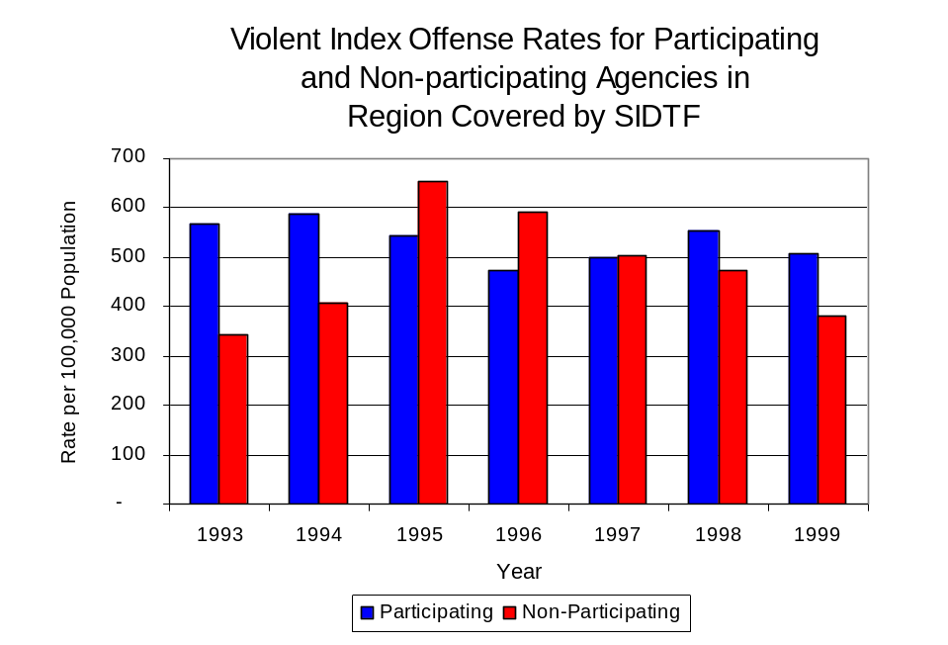
Source: ICJIA calculations using
Illinois State Police and U.S. Census Bureau data
Figure 1

Across the 30 individual local law enforcement agencies covered by SIDTF’s jurisdiction, four agencies, the Eldorado Police Department, the Centralia Police Department, the Washington County Sheriff’s Office and the Benton Police Department, accounted for nearly one-third of all violent offenses reported to the police (Figure 2). Sixteen agencies had fewer than 35 violent offenses reported in 1999 and are excluded from Figure 2. When controlling for differences in the populations served by these law enforcement agencies, the violent Index offense rate ranged from zero to 1,768 violent Index offenses per 100,000 population.
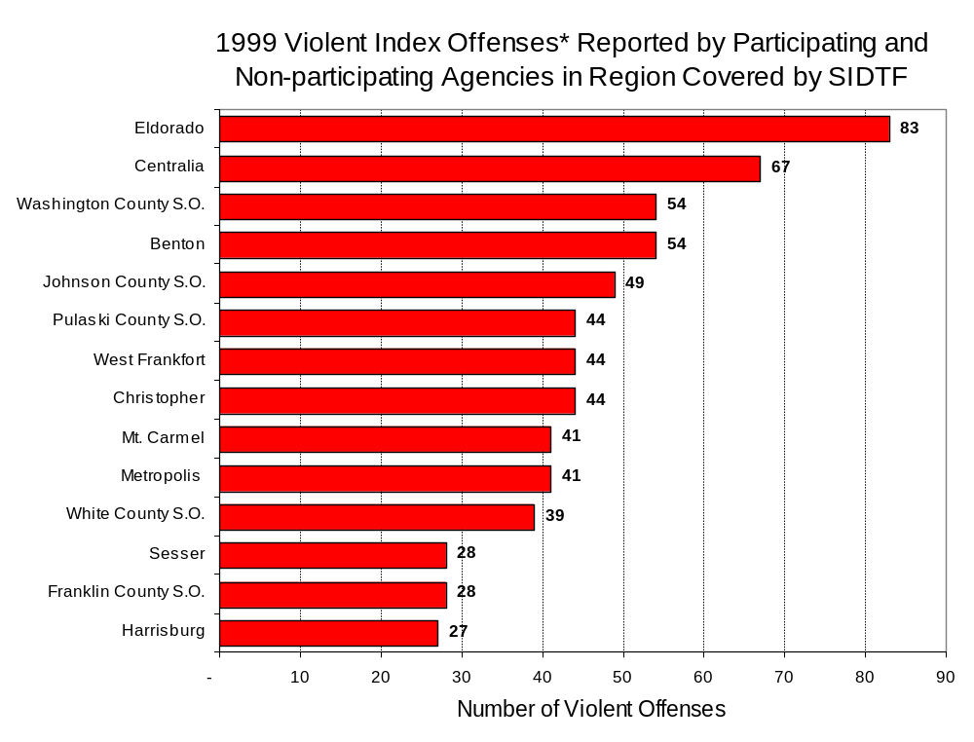
Source: Illinois State Police*Agencies reporting 25 or more violent offenses
Figure 2
An indicator of the workload that law enforcement agencies place on other components of the justice system is the number of arrests made by police, including those for violent and property Index offenses and drug offenses. Unlike offenses, which are what police must respond to, arrests represent those offenders who may eventually be processed through other components of the justice system, including the courts, county jails, and state and local correctional programs.

Between 1993 and 1999, the number of arrests for violent Index offenses made by law enforcement agencies in the region covered by SIDTF increased 3 percent, from 545 to 560. During the period analyzed, the violent Index arrest rate for the region covered by SIDTF increased 3 percent, from 343 offenses per 100,000 population in 1993 to 352 arrests per 100,000 population in 1999. However, the violent Index arrest rate in the participating agencies decreased 9 percent, from 397 to 363 offenses per 100,000 population, while the rate in the non-participating agencies increased 31 percent, from 256 to 336 offenses per 100,000 population (Figure 3).

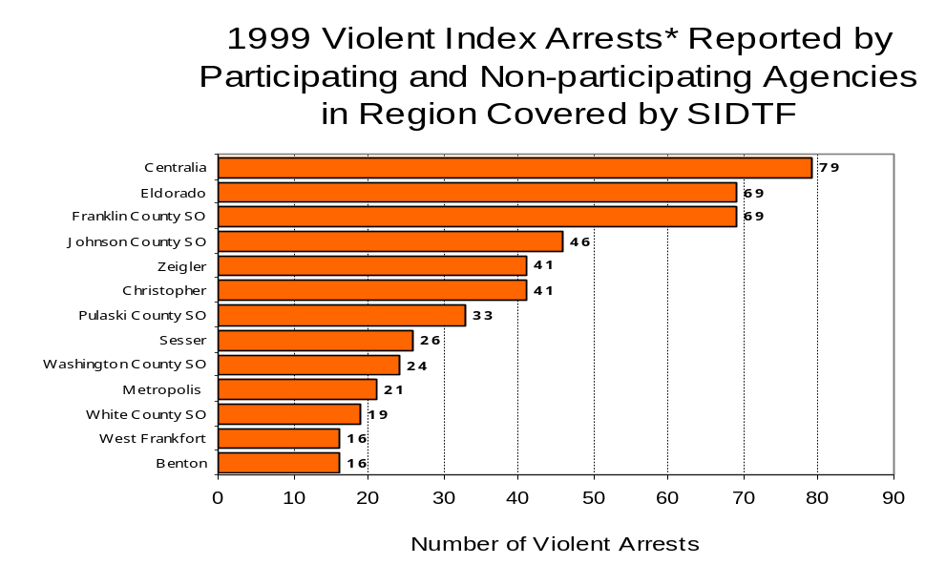
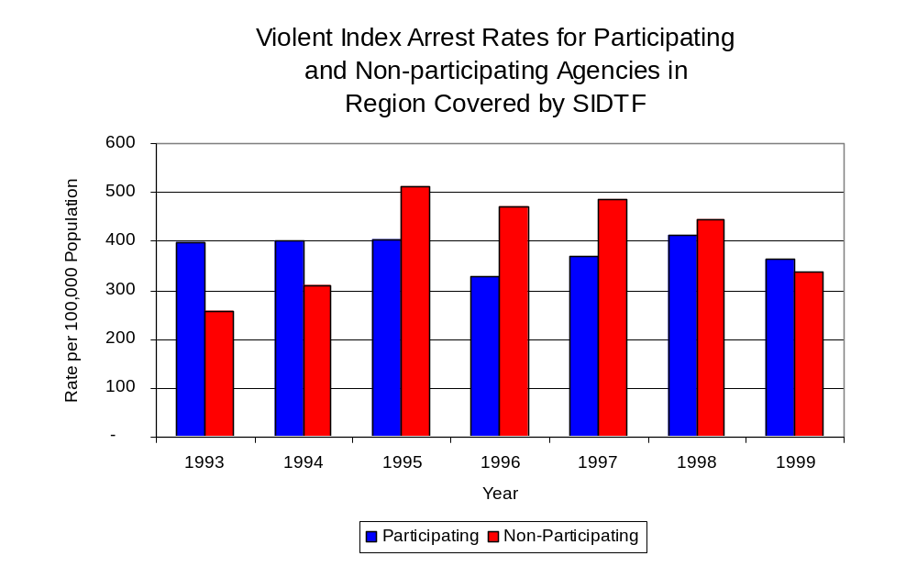
More than one-third (36 percent) of arrests for violent Index offenses occurring in the eight-county region covered by SIDTF were made by eight agencies. Eighteen agencies had fewer than 15 arrests for violent Index offenses reported in 1999 and are excluded from Figure 4. Of the 601 violent Index arrests made in 1999, the Centralia Police Department accounted for 13 percent, followed by the Eldorado Police Department and the Franklin County Sheriff’s Office (each 11 percent (Figure 4).
Figure 4
Source: Illinois State Police *Agencies reporting 15 or more violent offenses
Figure 3
Source: ICJIA calculations using
Illinois State Police and U. S. Census Bureau data

III. Trends in Drug Arrests

There are two sources of drug arrest data presented in this section. One source is the Illinois Uniform Crime Reporting (I-UCR) program that includes information submitted by local law enforcement agencies on the number of persons arrested for violations of Illinois’ Cannabis Control Act, Controlled Substances Act, Hypodermic Syringes and Needles Act, and Drug Paraphernalia Control Act. In addition, data on drug arrests made by Illinois’ MEGs and task forces are reported to the Illinois Criminal Justice Information Authority. In some jurisdictions, arrests made by the MEG or task force may be reported by both local law enforcement agencies through the I-UCR and to the Authority by the unit. In other jurisdictions, arrests made by the MEG or task force are only reported to the Authority by the unit. Therefore, in some instances drug arrests may be double counted – included in both local agency statistics reported to I-UCR and those of the MEG or task force. Currently there is no mechanism in place to ensure that drug arrest statistics are not being duplicated at both the local agency and MEG/task force level. This should be kept in mind when interpreting the information presented in the following section.

The majority of drug offenses in Illinois are violations of either the Cannabis Control Act – which prohibits the possession, sale and cultivation of marijuana – or the Controlled Substances Act – which prohibits the possession, sale, distribution or manufacture of all other illegal drugs, such as cocaine and opiates. Illinois also has various other laws prohibiting other drug-related activity. These include the Hypodermic Syringes and Needles Act – which prohibits the possession or sale of hypodermic instruments – and the Drug Paraphernalia Control Act – which prohibits the possession, sale or delivery of drug paraphernalia. In general, violations of Illinois Controlled Substances Act are considered to be more serious since they primarily involve cocaine, heroin, methamphetamine, and hallucinogens, and are almost all classified under Illinois law as felonies. The majority of cannabis and drug paraphernalia offenses encountered by police, on the other hand, tend to be misdemeanor-level offenses.

In 1999, local law enforcement agencies in the counties covered by SIDTF reported 959 arrests for drug law violations more than double the 382 arrests reported during 1993. Between 1993 and 1999, arrests for violations of Illinois’ Cannabis Control Act out-numbered arrests for violations of the Controlled Substances Act every years analyzed in Franklin, Johnson, Massac, Pulaski, Saline, Wabash, Washington and White counties combined. During the same period, the number of arrests for violations of the Cannabis Control Act in these eight counties combined, increased 35 percent, from 289 to 391. Arrests for violations of the Controlled Substances Act in the eight counties, combined, almost quadrupled, from 66 to 242. In addition, arrests for violations of the Drug Paraphernalia Control Act, enacted in 1993, increased dramatically, from 19 in 1993 to 290 in 1999. Much of this increase can be attributed to a 1994 addition to the Drug Paraphernalia Control Act, which included the possession of drug paraphernalia as a violation.

Because arrests for violations of the Drug Paraphernalia Control Act are frequently made in conjunction with other drug offense arrests, these arrests may be double-counted, thus skewing the actual number of drug arrests. Therefore, only arrests for violations of the Cannabis Control Act and Controlled Substances Act will be used for drug arrest comparisons between SIDTF and the participating and non-participating agencies.

During the period analyzed, the drug arrest rate for violations of the Cannabis Control and the Controlled Substances Acts combined, in the region covered by SIDTF increased 78 percent, from 223 arrests per 100,000 population in 1993 to 398 arrests per 100,000 population in 1999. Similarly, the drug arrest rate in the participating agencies, which has steadily increased in each of the last five years, increased 63 percent, from 293 to 479, while the drug arrest rate for non-participating agencies more than doubled, from 112 to 270 arrests per 100,000 population. The arrest rate for SIDTF increased 78 percent, from 122 to 218 arrests per 100,000 population (Figure 5). Thus, the drug arrest rate tended to be higher in the jurisdictions that did participate in SIDTF than in those jurisdictions that did not participate in SIDTF. Also, the drug arrest rate achieved by SIDTF was relatively close to that experienced by non-participating agencies and almost half the arrest rate achieved by participating agencies; meaning that the unit, with 30 officers, made almost as many arrests for violations of the Cannabis and Controlled Substances Act as did all of the non-participating agencies combined, and nearly one-half as many as all of the agencies participating in SIDTF, combined.
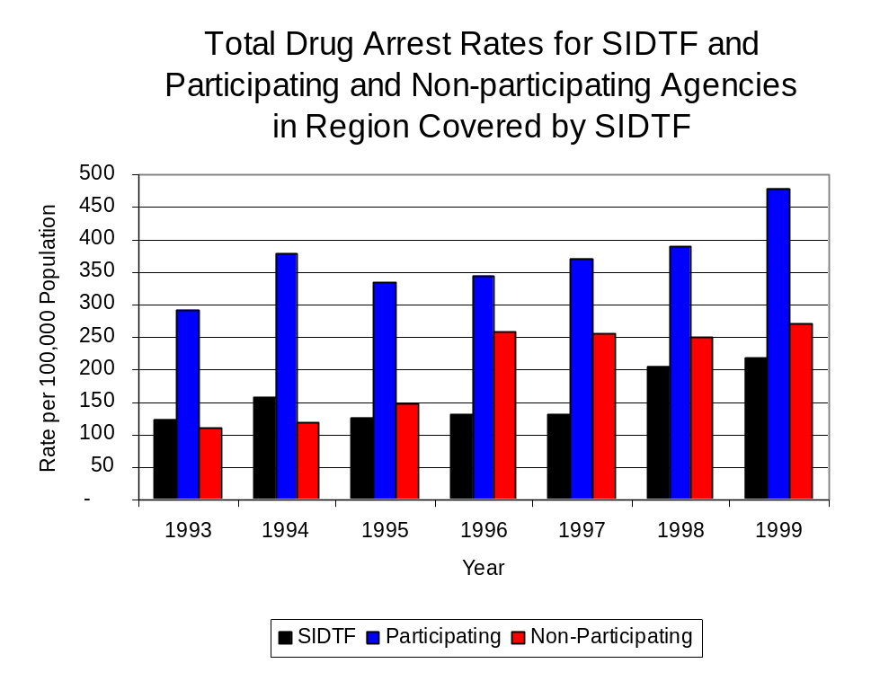
Source: ICJIA calculations using Illinois State Police, SIDTF and U.S. Census Bureau data
Figure 5

Across the individual local law enforcement agencies in the region covered by SIDTF, the number of cannabis and controlled substance arrests ranged from zero to 137. Of the 633 drug arrests made during 1999 in the eight-county region, three agencies accounted for nearly one-half (48 percent) of these drug arrests. Nineteen agencies had fewer than 15 drug arrests reported in 1999 and are excluded from Figure 6. The Johnson County Sheriff's Office accounted for 22 percent of the regional arrests, while the Centralia Police Department accounted for 16 percent and the White County Sheriff’s Office accounted for 10 percent of all drug arrests (Figure 6). Of the agencies listed in Figure 6, only three did not participate in SIDTF.

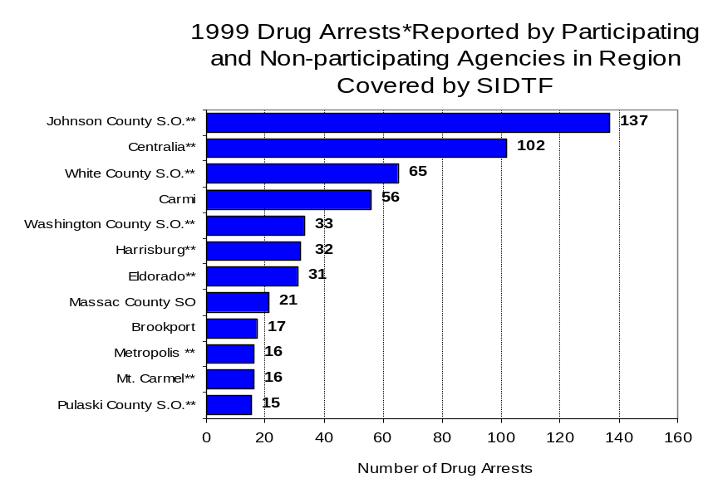
In addition to the dramatic difference in the number of drug arrests made, there are also
Figure 6
Source: Illinois State Police *Agencies reporting 15 or more drug arrests
**Agencies participating in SIDTF
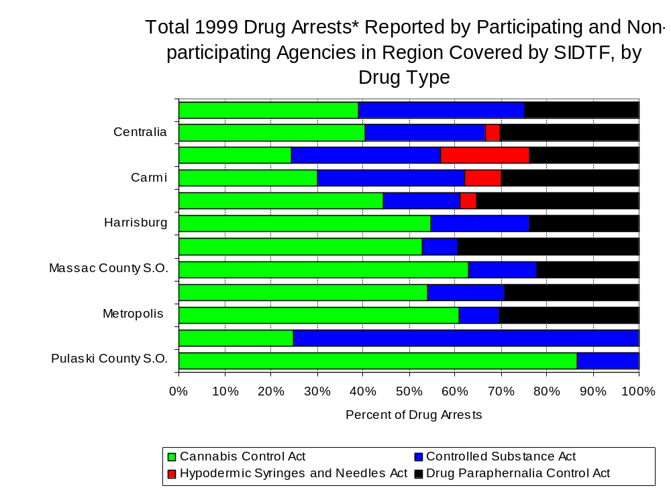
differences in the types of drug law violation arrests across the agencies in the region. In 1999, violations of the Cannabis Control Act and the Drug Paraphernalia Control Act accounted for the majority of arrests across most individual agencies in the region covered by SIDTF (Figure 7).
Source: Illinois State Police *Agencies reporting 15 or more drug arrests
Figure 7
Between 1993 and 1999, the number of combined cannabis and controlled substances arrests made by SIDTF increased 38 percent, from 154 to 213 (Figure 8). Unlike drug arrests made by most local police departments in the region, violations of the Controlled Substances Act accounted for the majority of drug arrests made by SIDTF throughout most of the period analyzed. During the period analyzed, the number of SIDTF arrests for violations of the Cannabis Control Act decreased 22 percent, from 76 to 59, while arrests for violations of the Controlled Substances Act almost doubled, from 78 to 154 (Figure 8).

Between 1993 and 1999, the proportion of drug arrests accounted for by violations of the Controlled Substances Act increased for participating and non-participating agencies. Similarly, for SIDTF, the proportion of drug arrests accounted for by controlled substance violations increased 85 percent between 1993 and 1999. In 1999, 72 percent of the drug arrests made by SIDTF were for violations of the Controlled Substances Act, compared to 39 percent in 1993. Among participating agencies, arrests for controlled substances violations accounted for 39 percent of the drug arrests made during 1999, compared to 21 percent in 1993. Similarly, among the non-participating agencies, 35 percent of 1999 arrests involved controlled substance Act violations, compared to 11 percent during 1993. Thus, arrests by SIDTF were more likely than arrests by either participating or non-participating agencies to involve violations of Illinois’ Controlled Substances Act, as opposed to the Cannabis Control Act. One interpretation of this pattern may be that SIDTF is more focused than local departments in regards to who they are targeting and arresting. SIDTF is also getting a more serious drug law violator, since violations of the Controlled Substances Act are more likely to involve felony-level offenses.
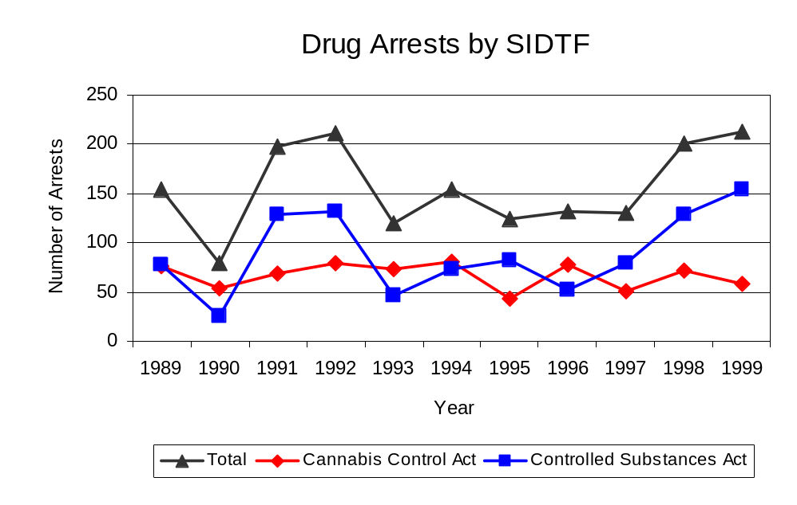
Source: SIDTF
Figure 8

The data presented below represent the percent of total drug arrests made in the eight-county region accounted for by SIDTF. An upper and lower bound is shown in Figure 9 which accounts for whether or not the units numbers are counted as part of the UCR submissions made by participating departments (which is unknown at this point). The upper bound indicates the percentage of arrests if none of the SIDTF arrests are included in the UCR submissions. The lower bound indicates the percentage if all of the SIDTF arrests are included in the UCR submissions. It is estimated that the proportion of all drug arrests in the jurisdictions of those agencies participating in SIDTF accounted for by SIDTF was between 29 to 42 percent in 1993, and increased to between 31 to 46 percent in 1999. Thus, despite the fact that the officers assigned to SIDTF accounted for a small proportion of total officers in the region, they accounted for a relatively large proportion of the drug arrests in the region.
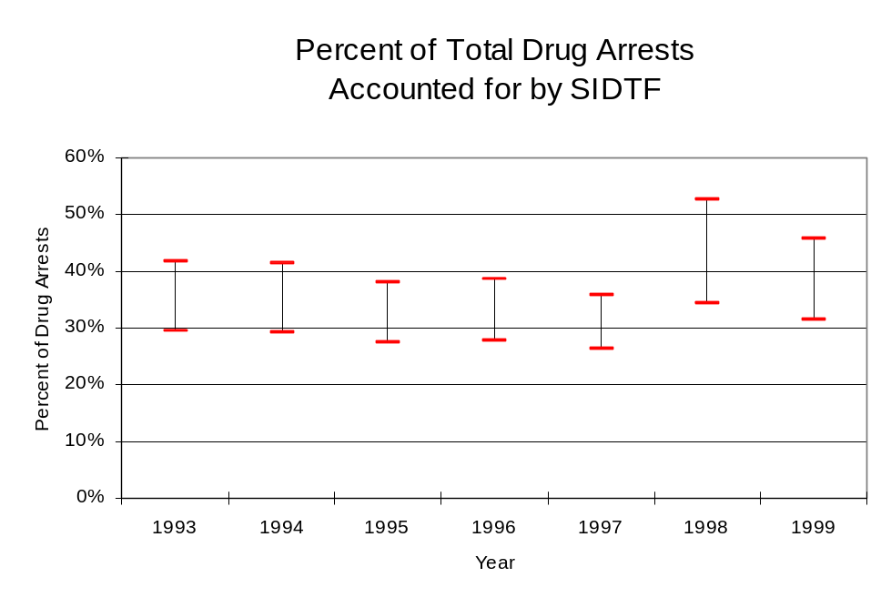
ICJIA calculations using Illinois State
Police and SIDTF data
Figure 9
The number of arrests for violations of Illinois’ Cannabis Control Act in Franklin, Johnson, Massac, Pulaski, Saline, Wabash, Washington and White counties totaled 392 in 1999, 34 percent more than the 292 arrests made for cannabis violations in 1993. Between 1993 and 1999, the proportion of all drug arrests accounted for by violations of the Cannabis Control Act in the eight-county region decreased 24 percent, falling from 81 percent to 62 percent. Agencies participating in SIDTF accounted for the largest portion (72 percent) of the total number of arrests for cannabis violations. SIDTF reported a total of 59 arrests for cannabis violations in 1999, 28 percent of the unit's drug arrests.

During the period analyzed, the cannabis arrest rate for the region covered by SIDTF increased 34 percent, from 184 arrests per 100,000 population in 1993 to 247 arrests per 100,000 population in 1999. The cannabis arrest rate in the participating agencies increased 25 percent, from 233 to 291 arrests per 100,000 population, while the arrest rate in the non-participating agencies increased 67 percent from 105 to 176 arrests per 100,000 population. The cannabis arrest rate for SIDTF, on the other hand, decreased 19 percent, from 74 to 60 arrests per 100,000 population (Figure 10). Thus, the arrest rate for violations of the Cannabis Control Act was higher in the area served by participating than in combined jurisdictions of the non-participating agencies.

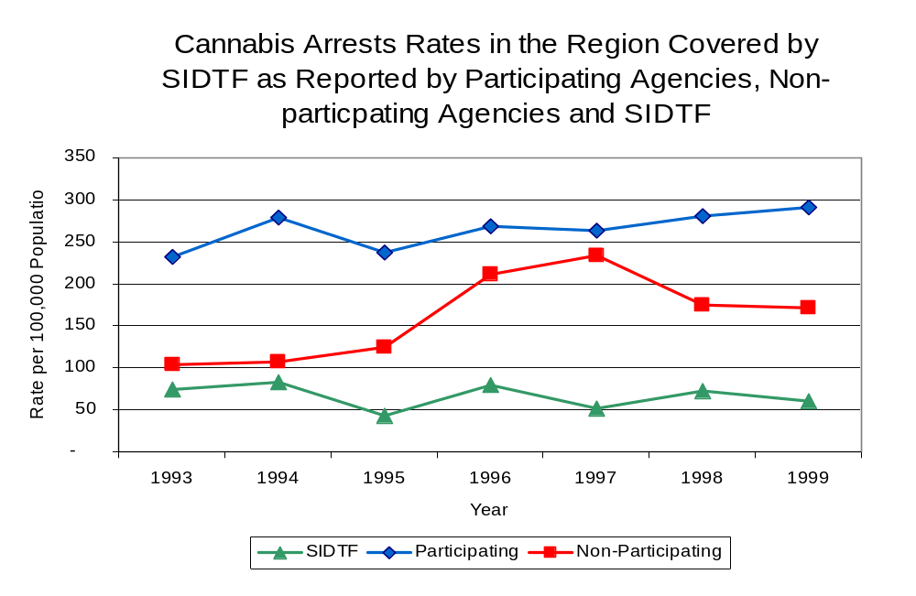
Source: ICJIA calculations using
Illinois State Police and SIDTF data
Figure 10

The data presented in Figure 11 represent the percent of cannabis arrests made in the jurisdictions of participating agencies accounted for by SIDTF. An upper and lower bound is shown which accounts for whether or not the unit’s numbers are counted as part of the UCR submissions made (which is unknown at this point). The upper bound indicates the percentage of arrests if none of the SIDTF arrests are included in the UCR submissions. The lower bound indicates the percentage if all of the SIDTF arrests are included in the UCR submissions. It is estimated that the proportion of cannabis arrests in the eight-county region accounted for by SIDTF was between 24 to 32 percent in 1993, but decreased to between 17 to 21 percent in 1999.

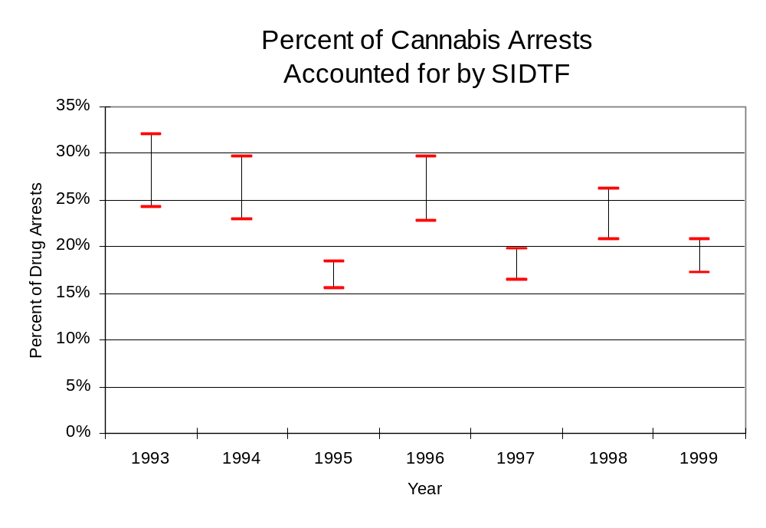
ICJIA calculations using Illinois State
Police and SIDTF data
Figure 11
In Franklin, Johnson, Massac, Pulaski, Saline, Wabash, Washington and White counties the number of arrests for violations of Illinois’ Controlled Substances Act increased nearly three-fold between 1993 and 1999, from 67 to 242. Between 1993 and 1999, the proportion of all drug arrests accounted for by violations of the Controlled Substances Act in the eight-county region doubled from 19 percent to 38 percent. In 1999, SIDTF reported 154 arrests for controlled substance violations, 72 percent of all drug arrests reported to the Authority by the unit.

Between 1993 and 1999, the arrest rate for controlled substances act violations for the region covered by SIDTF more than tripled, from 42 to 152 arrests per 100,000 population (Figure 12). The controlled substances arrest rate in the participating agencies more than tripled, from 60 to 188 arrests per 100,000 population, while the arrest rate in the non-participating agencies increased more than six-fold, from 13 to 96 arrests per 100,000 population. The controlled substances arrest rate for SIDTF more than tripled, from 48 to 158 arrests per 100,000 population (Figure 12). Thus, the arrest rate for violations of the Control Substances Act was higher in the participating agencies than the non-participating agencies.
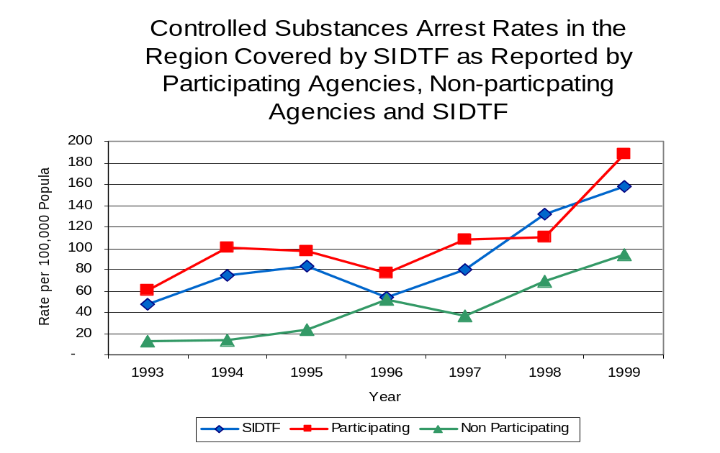
The data presented in Figure 13 represent the percent of controlled substances arrests made in the jurisdictions of participating agencies accounted for by SIDTF. An upper and lower bound is shown which accounts for whether or not the units numbers are counted as part of the UCR submissions (which is unknown at this point). The upper bound indicates the percentage of arrests if none of the SIDTF arrests are included in the UCR submissions. The lower bound indicates the percentage if all of the SIDTF arrests are included in the UCR submissions. It is estimated that the proportion of controlled substances arrests in the eight-county region accounted for by SIDTF was between 44 to 80 percent in 1993, but decreased to between 46 to 84 percent in 1999. Thus, while SIDTF represented a small proportion of all officers, SIDTF accounted for a large proportion of all arrests made for violations of the Controlled Substances Act.
Figure 12
Source: ICJIA calculations using Illinois State Police and SIDTF data
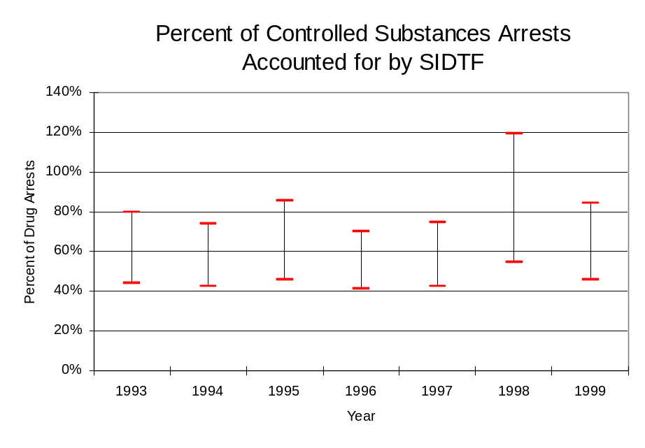
ICJIA calculations using Illinois State
Police and SIDTF data
Figure 13

The majority of all drug arrests reported by SIDTF are for delivery. Between 1993 and 1999, the number of drug delivery arrests made by SIDTF increased 78 percent, from 98 to 174. Arrests for drug delivery accounted for 78 percent of all drug arrests made by SIDTF between 1993 and 1999. When cannabis and controlled substance arrests were examined separately, during the period analyzed, arrests for delivery of controlled substances accounted for 85 percent of the total number of arrests made for violations of the Controlled Substance Act, whereas, arrests for the delivery of cannabis accounted for 67 percent of all arrests for violations of the Cannabis Act. Thus, the number of arrests and the proportion of delivery arrests followed similar trends.

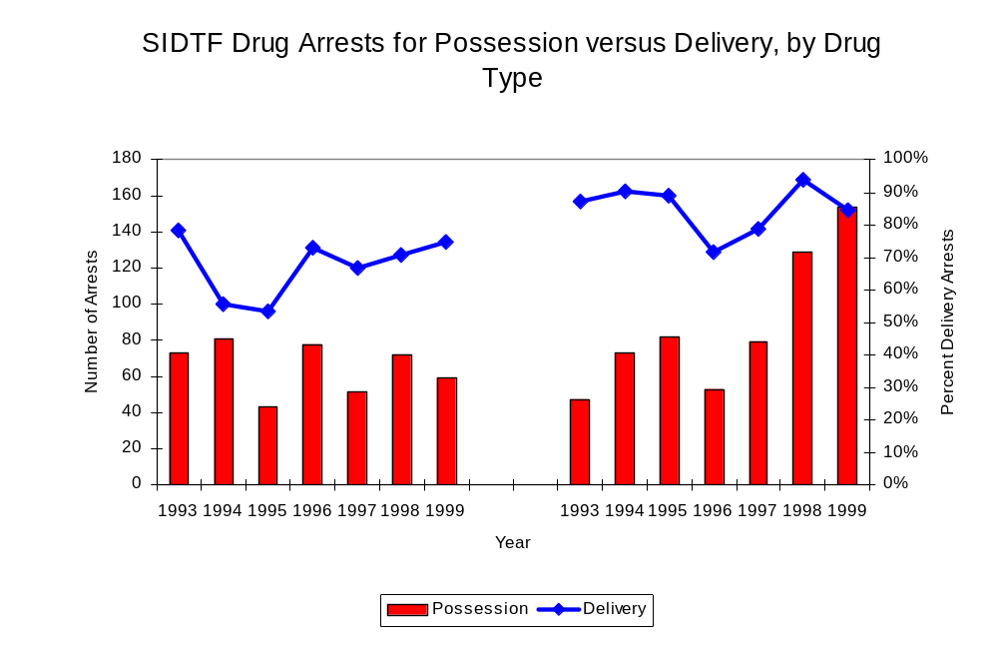
Figure 14
Source: ICJIA calculations using SIDTF data
Cannabis Control Act

Controlled Substances Act

IV. Trends in Drug Seizures

Drugs seized by law enforcement agencies are another indicator of the extent and nature of illegal drug trade in a jurisdiction. When illegal drugs are seized by law enforcement agencies, all or a portion of the total amount seized is submitted to a crime lab for analysis. Most agencies submit drugs to one of the Illinois State Police crime labs. These labs record the quantity of drugs submitted from each county. This section discusses trends in the quantities of illegal drugs seized and submitted to the Illinois State Police from local law enforcement agencies in Franklin, Johnson, Massac, Pulaski, Saline, Wabash, Washington and White counties as well as the quantities of drugs seized by SIDTF. It is important to note, however, that while SIDTF data report the total quantities of drugs actually seized, local agency data only represent the quantities of seized drugs that are submitted to the Illinois State Police for analysis. County-level cannabis, cocaine and methamphetamine seizure rates for Illinois' 102 counties are provided in maps located in the Appendix of this report.

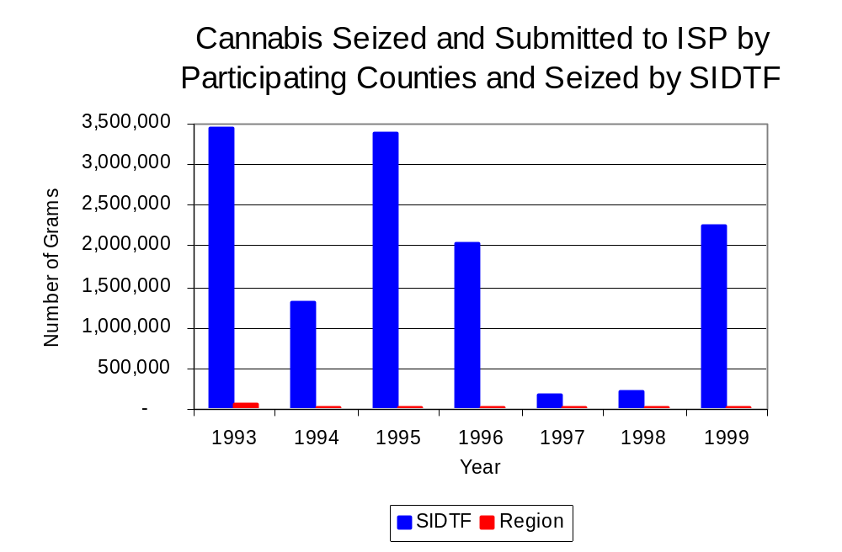
As in most Illinois jurisdictions, cannabis accounts for the majority of illegal drugs seized in the eight-county region covered by SIDTF. The quantity of cannabis seized and submitted by law enforcement agencies in Franklin, Johnson, Massac, Pulaski, Saline, Wabash, Washington and White counties fell dramatically, from 64,700 grams in 1993 to 11,374 grams in 1999. The quantity of cannabis seized by SIDTF also decreased between 1993 and 1999, from 3.4 million grams to 2.2 million grams (Figure 15). In 1999, SIDTF's cannabis seizure rate of 2.3 million grams per 100,000 population was dramatically higher than the statewide cannabis seizure rate of 31,533 grams per 100,000 population and the seizure rate of 7,156 grams per 100,000 population in the eight-county region covered by SIDTF. Thus, almost all cannabis seized and submitted between 1993 and 1999 came from arrests made by SIDTF (Map 2).
Figure 15
Source: Illinois State Police and SIDTF

Between 1993 and 1999, a combination of crack and powder cocaine has accounted for a small proportion of drugs seized in the eight-county region covered by SIDTF. However, the quantity of cocaine seized and submitted by law enforcement agencies in Franklin, Johnson, Massac, Pulaski, Saline, Wabash, Washington and White counties increased 37 percent, from 120 grams in 1993 to 165 grams in 1999. Between 1993 and 1999, the quantity of cocaine seized by SIDTF increased 16 percent, from 460 grams to 535 grams.

Due to the relatively small quantities of powder cocaine and crack cocaine seized in the region and by SITDT, the proportion accounted for by powder cocaine fluctuated widely (Figure 16). In 1999, SIDTF's cocaine seizure rate of 548 grams per 100,000 population was more than five times higher than the cocaine seizure rate of 104 grams per 100,000 population in the eight-county region covered by SIDTF, but dramatically less than the statewide cocaine seizure rate of 15,735 grams per 100,000 population (Map 3).
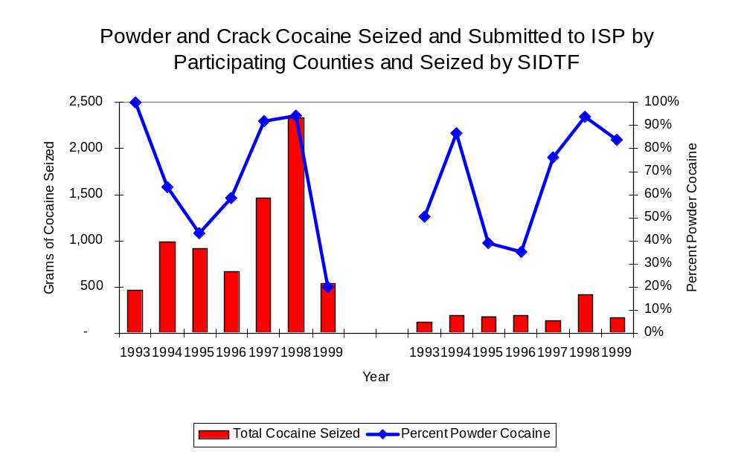
Figure 16
Source: Illinois State Police and SIDTF
SIDTF
Region

The total quantity of illegal drugs seized and submitted by law enforcement agencies in Franklin, Johnson, Massac, Pulaski, Saline, Wabash, Washington and White counties decreased between 1993 and 1999, from 66,792 grams to 12,492 grams. On the other hand, the total quantity of illegal drugs seized by SIDTF has decreased 34 percent, from 3.4 million grams in 1993 to 2.3 million grams in 1999.

In recent years, there has been an increase in the quantity of methamphetamine seized. During 1999, more than 3,200 grams of methamphetamine were seized by SIDTF, for a seizure rate of 3,219 per 100,000 population. This rate was significantly higher than the rate of 185 grams per 100,000 population in the eight-county and the statewide methamphetamine seizure rate of 98 grams per 100,000 population in 1999 (Map 4).

Trends in Prosecutions for Drug Offenses and All Felonies

Although Illinois has one of the best court reporting systems in the country, the Administrative Office of the Illinois Court only collects information regarding the aggregate number of court filings. Currently, there are no statewide data available on court filings by offense type. The Administrative Office of the Illinois Courts reports data on felony criminal court cases. After screening a case and deciding it warrants further action, the state’s attorney must file formal charges in court. Felony cases can be punished by a probation term up to four years and incarceration for more than one year.

Between 1989 and 1999, the number of felony filings in the eight-county region covered by SIDTF increased 42 percent, from 958 to 1360 (Figure 17).
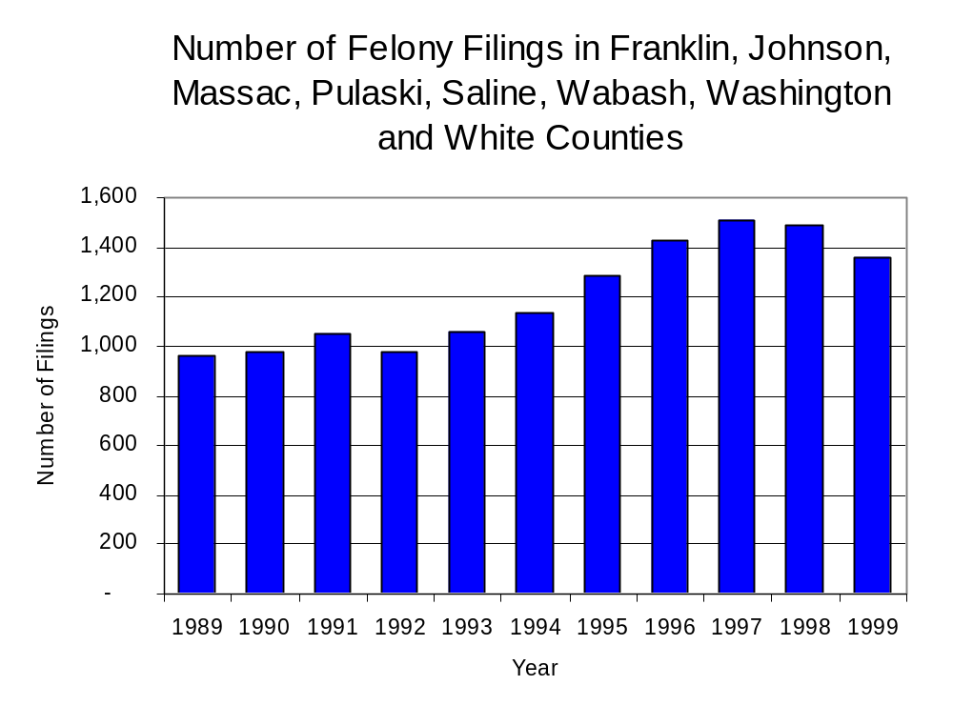
Figure 17
Source: Administrative Office of the Illinois Courts

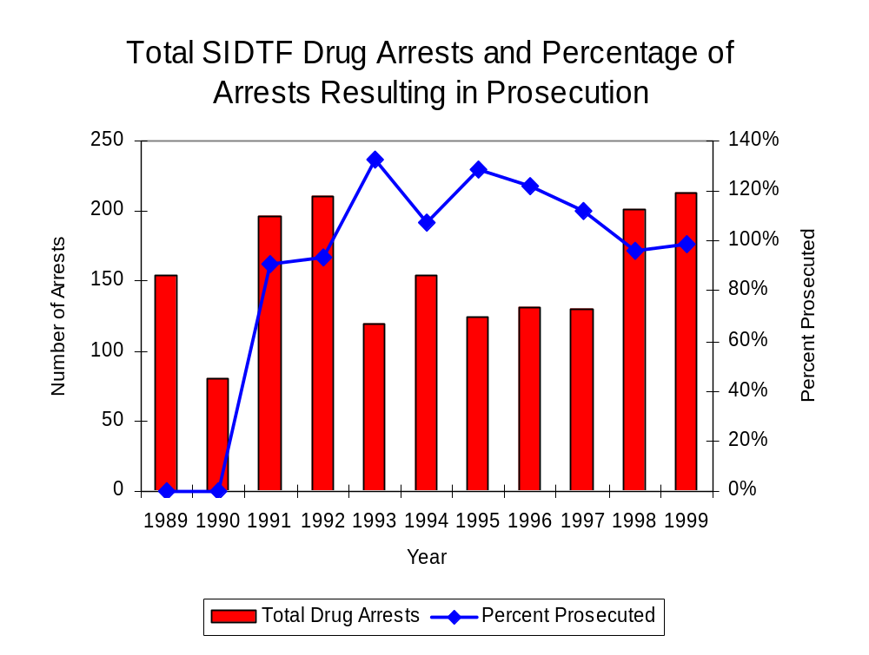
Between 1989 and 1999, there were a total of 1,574 drug prosecutions initiated as a result of SIDTF arrests in Franklin, Johnson, Massac, Pulaski, Saline, Wabash, Washington and White counties. During this time, the number of SIDTF drug arrests increased 38 percent, from 154 arrests in 1989 to 213 arrests in 1999 (Figure 18). Between 1991 and 1999, nearly every drug arrest (92 percent) by SIDTF resulted in prosecution. No prosecutions were reported 1989 and 1990. In some years, the proportion of arrests resulting in a prosecution exceeded 100 percent. this may be due to some slight differences in the timing of an arrest and the filings of charges. It could also be due to charges, rather than defendants, being reported by the unit. Also, some offenders have charges filed, and a subsequent warrant issued, without an arrest taking place.
Figure 18
Source: SIDTF

Between 1989 and 1999, 71 percent (1,123) of the 1,574 drug offenders who were prosecuted as a result of SIDTF activity were convicted. Convictions for controlled substances accounted for 58 percent of all SIDTF initiated convictions during the period analyzed.

VI. Trends in Percent of Convicted Drug Offenders Sentenced to Prison

Anyone convicted of a felony in Illinois can be sentenced either to prison or probation, or receive conditional discharge. A number of factors influence the type and length of sentence imposed on convicted felons, including the severity of the crime, the offender’s criminal and social history, safety of the community and legislation affecting certain types of offenses. For some types of convictions, a sentence to prison is required by state statute.

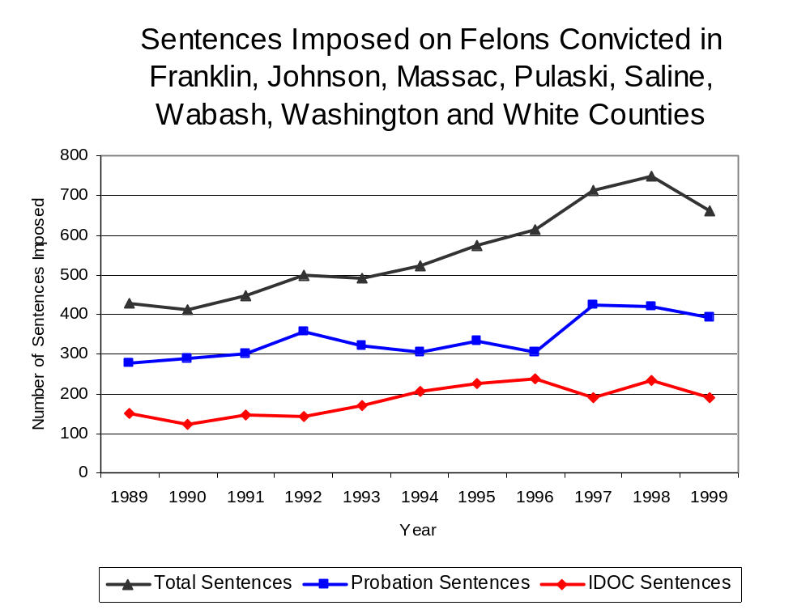
Between 1989 and 1999, the number of offenders convicted of a felony and sentenced in the eight-county region covered by SIDTF increased 54 percent, from 429 to 661. During that period, the number of convicted felons sentenced to the Illinois Department of Corrections (IDOC) increased 27 percent between 1989 and 1999, from 149 to 189, the proportion of felons sentenced to IDOC decreased slightly during the same period, from 35 percent to 29 percent of total felony sentences. In 1999, 391 probation sentences were imposed on convicted felons, 41 percent more than the number of probation sentences in 1989 (Figure 19). However, the proportion of felons sentenced to probation decreased from 65 percent in 1989 to 59 percent in 1999. Sentences other than prison or probation account for the remaining 12 percent of felony sentences imposed in 1999.
Figure 19
Source: Administrative Office of the Illinois Courts

Between 1991 and 1999, the number of SIDTF drug offenders convicted and sentenced increased from 96 to 139, a 45 percent increase. During the period analyzed, the number of convicted SIDTF drug offenders sentenced to probation increased from 57 in 1991 to 84 in 1999. Similarly, the number of convicted SIDTF drug offenders sentenced to jail increased from nine to 19 and the number of drug offenders sentenced to prison increased from 30 to 36 (Figure 20). In 1999, among those SIDTF drug offenders convicted and sentenced, probation sentences accounted for the largest proportion (60 percent), followed by prison sentences (26 percent) and jail sentences (14 percent).
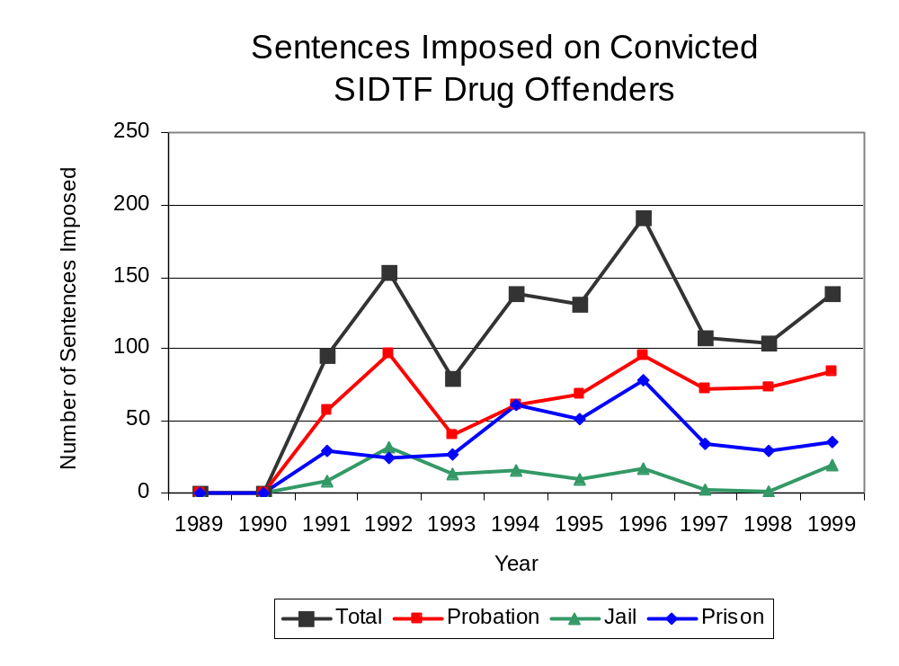
Figure 20
Source: SIDTF

Between state fiscal years 1989 and 1999, the number of new court commitments to IDOC’s Adult Division for drug offenses from the eight-county region covered by SIDTF increased from ten to 33. The number of drug offender admissions by SIDTF also increased from zero to 37 between 1989 and 1999 (Figure 21). During the period analyzed, prison sentences resulting from SIDTF cases accounted for 72 percent of all drug-law violators sentenced to prison from the region where SIDTF operates. However, in some years, prison sentences resulting from SIDTF cases far exceeded the number of drug-law violators sent to prison from the eight-county region covered by SIDTF. This discrepancy may be due to the fact that some offenders sentenced to prison resulting from SIDTF cases may have been sentenced for multiple charges, and each charge was reported to the Authority, whereas the data provided for by IDOC represent only the most serious charge for which offenders were sentenced.

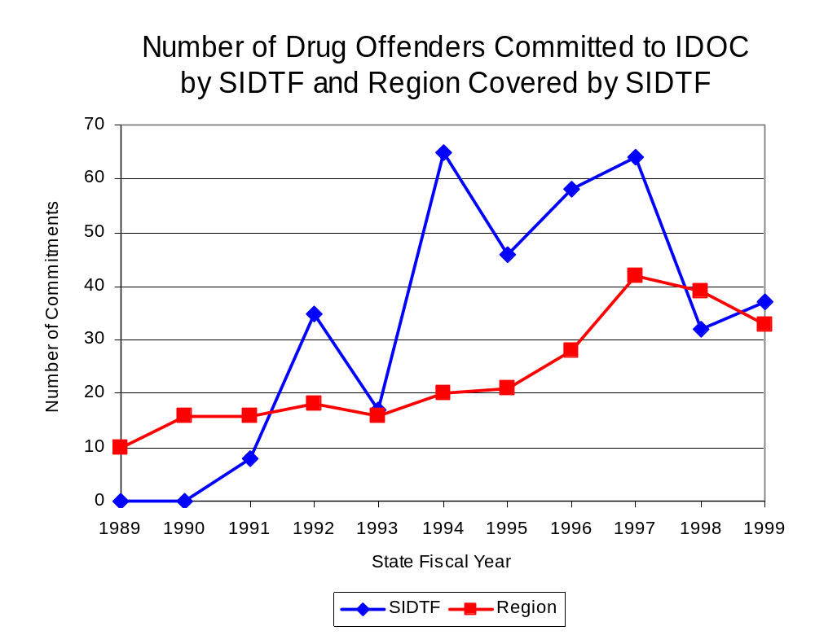
Figure 21
Source: Illinois Department of Corrections and SIDTF

During the period analyzed, drug offenders accounted for an increasing proportion of adults convicted and sentenced to prison from Franklin, Johnson, Massac, Pulaski, Saline, Wabash, Washington and White counties. In 1989, drug offenses accounted for 8 percent of all commitments to IDOC, compared to 17 percent in 1999 (Figure 22).

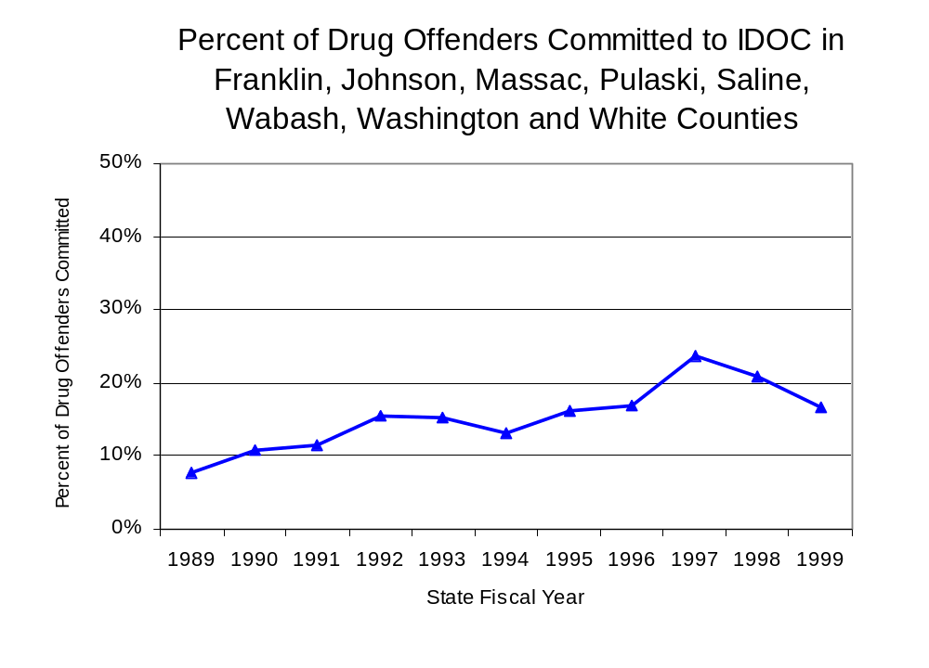
Figure 22
Source: Illinois Department of Corrections

Penalties for drug offenses were also examined between 1993 and 1999. Class 4 felonies accounted for the largest proportion (50 percent) of sentences to IDOC for drug offenses, followed by Class 3 felonies (18 percent), Class 2 and Class 1 felonies (17 percent and 12
percent) and Class X felonies (3 percent). Between 1993 and 1999, the number of prison admissions for the specific felony class offenses varied, although there was a clear increase in the number of Class 4 felony drug offenses admissions (Figure 23).

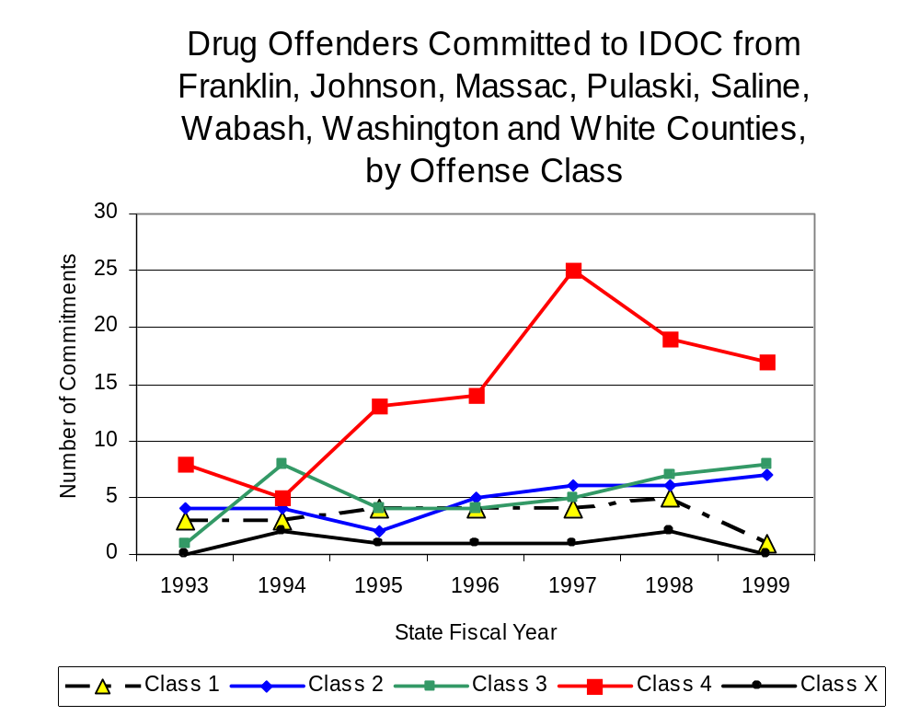
Figure 23
Source: Illinois Department of Corrections

Despite the increase in Class 4 felony sentences to IDOC between 1993 and 1999, the mean sentence length for Class 4 felonies remained stable at 2.2. As a result of the increase in Class 4 felony admissions, overall sentence lengths for drug offenses decreased between 1993 and 1999, from 3.8 years to 2.9 years.

Based on data collected from the 2000 Illinois Adult Probation Outcome Study, just over 10 percent (12.5 percent) of all adults discharged from probation in Franklin, Johnson, Massac, Pulaski, Saline, Wabash, Washington and White counties combined during the study period (November 2000) were convicted of drug-law violations.

VII. Trends in Drug Treatment Admissions in SIDTF Region by Drug Type

In addition to considering indicators of the extent and nature of drug abuse as reported through the criminal justice system (for example, arrests and prison sentences), there are indicators of substance abuse available from other Illinois social service agencies. Overseeing and supporting treatment for substance users, whether they are referred from the criminal justice system or elsewhere, is the responsibility of the Illinois Department of Human Services’ Office of Alcoholism and Substance Abuse (OASA). It is important to note, however, that while OASA data represent the majority of the overall demand for substance abuse treatment in the state, some private programs provide treatment services to a smaller but significant number of clients who may not be included in the state’s reporting system.

In state fiscal year 1999, OASA reported 2,154 admissions for alcohol or drug abuse treatment from Franklin, Johnson, Massac, Pulaski, Saline, Wabash, Washington and White counties, more than double the 990 admissions in 1989 (Figure 24). Among the 2,154 admissions to substance abuse treatment in state fiscal year 1999, 70 percent (1,507) reported alcohol as their primary substance of abuse, while abuse of illicit substances accounted for 28 percent.

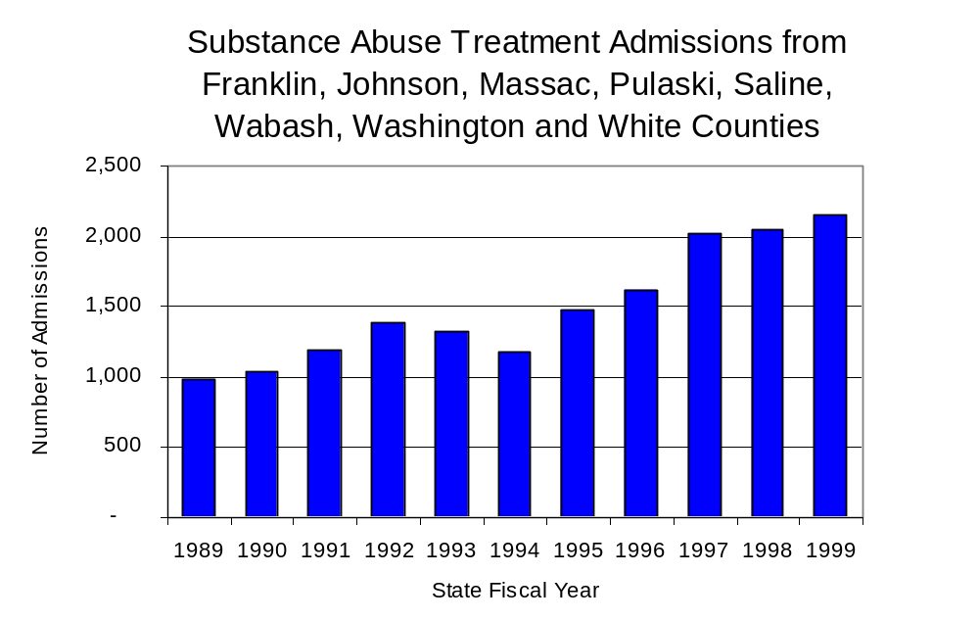
Figure 24
Source: Illinois Department of Human Services’
Office of Alcoholism and Substance Abuse
While drug treatment admissions can be considered a measure of the demand placed on a specific component of the human services system within Illinois, the extent and nature of drug treatment admissions could also be indicative of the substance abuse problem within a particular region. In some respects, the characteristics of those admitted to drug treatment can be considered a profile of the most serious drug abusers in the community, since admission to treatment requires a documented, formal assessment of a drug problem and a level of substance abuse warranting treatment. By comparing the types of drugs of abuse reported by those admitted to substance abuse treatment with the types of drugs involved in law enforcement agency arrests, one can get a sense of the degree to which arrests reflect the drugs which are most problematic within a community.

In the following analyses, the percent of arrests accounted for by drugs classified under Illinois’ Controlled substances Act (primarily cocaine, heroin, and methamphetamine) versus the Cannabis Control Act (marijuana) across the participating agencies combined, non-participating agencies combined, and SIDTF are compared to the proportion of drug treatment admissions accounted for by these groups of substances. From these comparisons, a number of general conclusions can be made. First, the proportion of arrests made by both participating and non-participating agencies accounted for by marijuana (Cannabis Control Act) was very close to the proportion of drug treatment admissions from the covered region accounted for by marijuana. Thus, there is considerable convergence between the drugs involved in arrests made by these agencies and treatment admission. On the other hand, the majority of arrests by SIDTF were for drugs other than marijuana (Controlled Substances Act). While SIDTF arrests may not reflect the most widely available and used drug in the region, they tend to involve the substances considered to be most serious (i.e., felony versus misdemeanor). They do not, however, tend to involve the substances individuals are seeking and receiving treatment for (Figure 25).

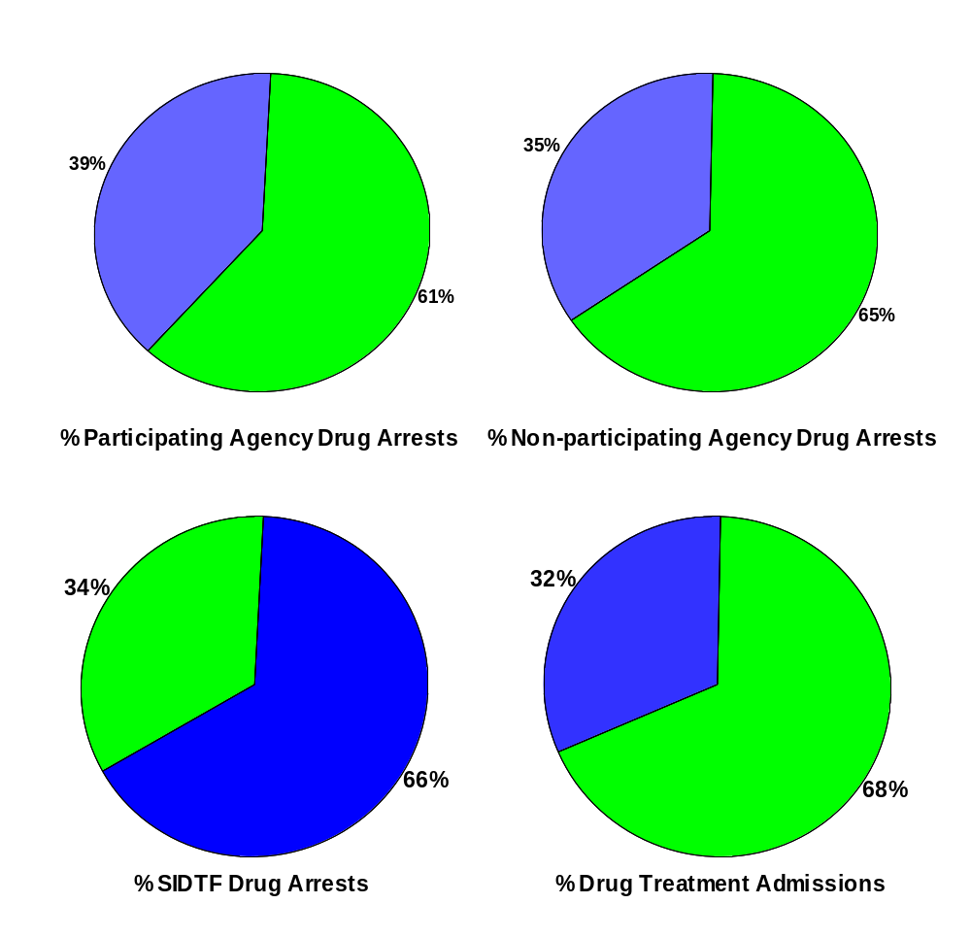
CannabisControlled Substances
Comparison of Drug Arrests by SIDTF and Participating and Non-participating Agencies vs. Drug Abuse Treatment Admissions in Franklin, Johnson, Massac, Pulaski, Saline, Wabash, Washington and White Counties, 1999
Source: Illinois Department of Human Service's Office of Alcoholism and Substance Abuse and SIDTF
Figure 25

VIII. Trends in Drug Exposed Births

Illinois continues to experience the effects of prenatal substance abuse. In Illinois, if a baby is born and thought to have been exposed to illegal substances or alcohol, either through observation by physicians or toxicology tests, the case is reported to the Illinois Department of Children and Family Services. These cases are then investigated by DCFS to verify the child’s prenatal exposure to either alcohol or illegal substances. Between state fiscal years 1989 and 1999, nearly one-half (50) of Illinois’ 102 counties reported at least one case of a substance-affected infant.

Between state fiscal years 1989 and 1999, the number of drug-exposed infant cases reported in the eight-county region covered by SIDTF totaled 39, and showed no discernable trend during the period examined. Between state fiscal years 1989 and 1999, 12 cases, or 31 percent of all cases reported, were verified by a DCFS investigation as involving prenatal drug use (Figure 26).

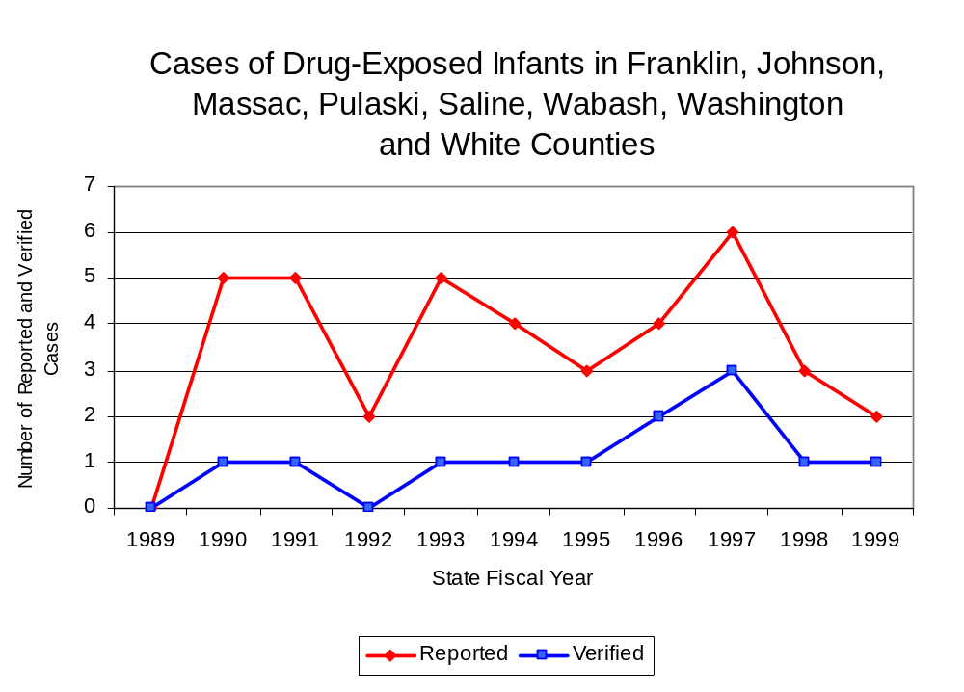
Source: Department of Children and Family Services
Figure 26

IX. Summary of Drug Situation

Although the distribution of illegal drugs is difficult to measure precisely, data obtained from criminal justice sources can be helpful in estimating drug availability. Information from a recent survey of Illinois drug enforcement units, as well as the most up-to-date data available on drug price, are presented as indicators of the drug supply in Illinois.

In 1995, 1996 and 1998, the Authority conducted a survey of each MEG and task force in Illinois to gauge the perceived availability of drugs in the areas they cover. Questions were asked concerning the availability of specific drugs, and results were analyzed by region of the state. MEGs and task forces are classified as being either urban, rural or mixed urban/rural based upon the classification of the county(s) that each unit covers, and, for purposes of this report, are compared to the average of similar units.

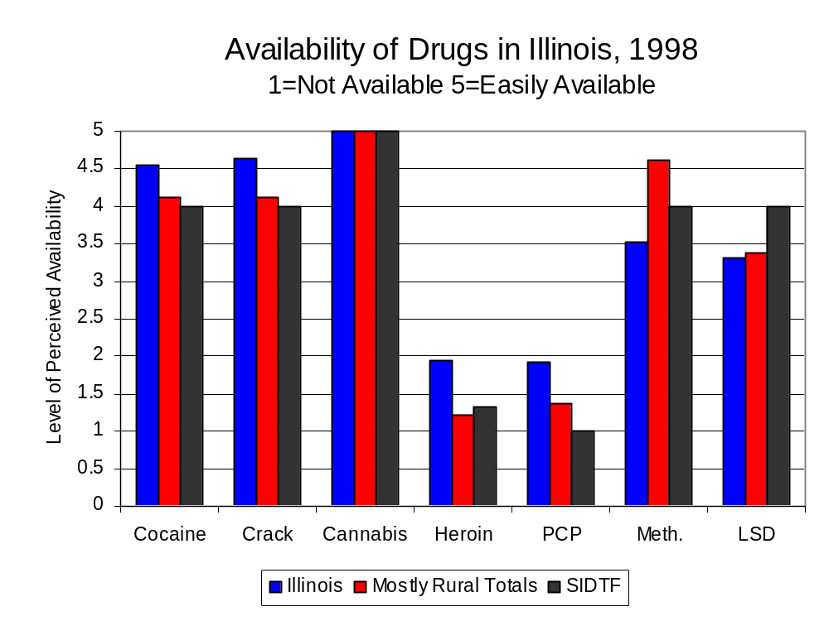
According to SIDTF survey responses, cannabis, cocaine, crack, methamphetamine and LSD, continued to be the most visible drugs on the street and were all reported to be “readily available” across all regions analyzed. While perceived availability of cannabis remained relatively unchanged in the eight-county region covered by SIDTF, the perceived availability of herion increased slightly since the 1996 survey, while all other drug types decreased in the region covered by SIDTF. Methamphetamine was reported as moderately available across Illinois but available to a somewhat greater degree in the region covered by SIDTF and by all MEGs and task forces in mostly urban regions. The perceived availability of all drugs, excluding cannabis, LSD and methamphetamine, tended to be greater across Illinois and in other mostly urban regions than in the region covered by SIDTF (Figure 27).
Figure 27
Source: Authority Survey of Illinois MEGs and task forces
Another market indicator that can be used to assess availability is drug price. Lower prices tend to suggest a sufficient supply to meet demand, while increasing prices indicate decreased availability.

Based on a statewide survey of MEG and task force units, the average price of cocaine, crack and methamphetamine appear to be relatively stable across all regions surveyed in 1998, while prices for heroin appear to vary somewhat across Illinois. The average price of cannabis, cocaine and heroin in the region covered by SIDTF increased between 1996 and 1998, as it did in the other mostly urban regions. The 1998 average price of cocaine reported by SIDTF was $100 per gram, compared to $98 per gram across Illinois and by all MEGs and task forces in other mostly urban regions (Figure 28). On the other hand, the average price of heroin in the region covered by SIDTF was reported as $100 per gram, lower than the price of $165 per gram across Illinois, but greater than the price of $88 per gram reported by all other MEGs and task forces in mostly urban regions. In 1998, the average price of cannabis was reported as approximately $4 per gram in the SIDTF region, $8 per gram in mostly urban regions and across Illinois.

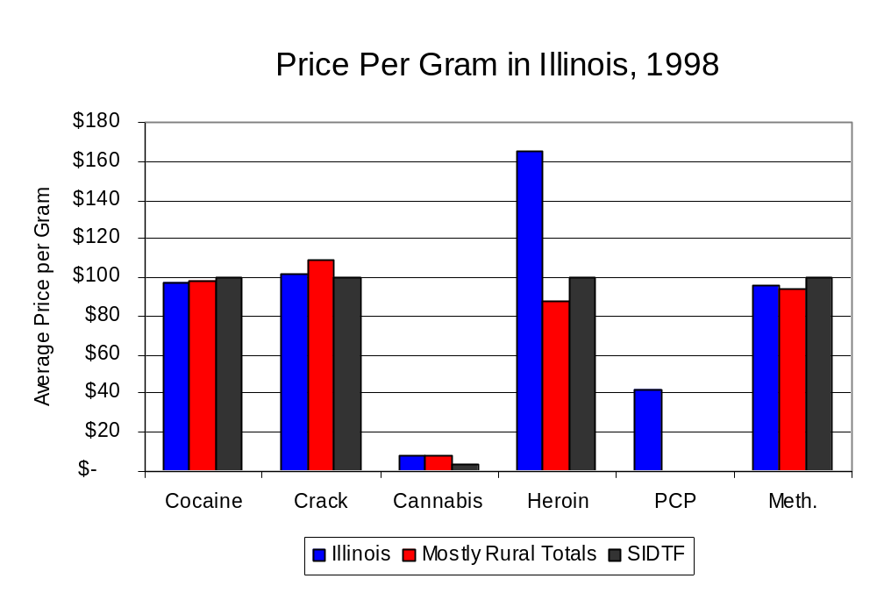
Figure 28
Source: Authority Survey of Illinois MEGs and task forces

X. Appendices
1999 Percent of Illinois'
County-level Population Covered by an Authority-funded Multi-jurisdictional Enforcement Group or Task Force
Map 1
* Shaded counties indicate that at least one law enforcement agency within the county participates in a MEG or task force
Percent of County Population Covered by MEG or Task Force

1999 Illinois
Cannabis
Seizure Rates, by County
Map 2
Cannabis Seizure Rate
(rate per 100,000 population)
1999 Illinois
Cocaine
Seizure Rates, by County
Map 3
Cocaine Seizure Rate
(rate per 100,000 population)
1999 Illinois Methamphetamine
Seizure Rates, by County
Map 4
Methamphetamine Seizure Rate
(rate per 100,000 population)

Bibliography

Administrative Office of the Illinois Courts, Annual Report to the Supreme Court of Illinois.
1989 through 1999 reports, Springfield, Illinois.

Administrative Office of the Illinois Courts’ Probation Division, Statewide Probation Data
Report. 1989 through 1999 reports, Springfield, Illinois.

Illinois Department of Human Services’ Office of Alcoholism and Substance Abuse. Data
provided for state fiscal years 1989 through 1999, Springfield, Illinois.

Illinois Department of Children and Family Services, Child Abuse/Neglect Statistics Report,
1989 through 1999 reports, Springfield, Illinois.

Illinois Department of Corrections. Data provided for fiscal years 1989 through 1999,
Springfield, Illinois.

Illinois State Police, Crime in Illinois. 1993 through 1999 reports, Springfield, Illinois.

Illinois State Police, Drug Statistics Report. Monthly reports, January 1989 through
December 1999, Springfield, Illinois.

Southern Illinois Drug Task Force. Monthly reports, January 1989 through December
1999, Marion, Illinois.

U.S. Bureau of the Census.


George H. Ryan, Governor
Peter B. Bensinger, Chairman
Candice M. Kane, Executive Director

The Centralia Police Department, which is located in Marion County, Illinois, also participated in this task force. Therefore, to accurately reflect the rates calculated for this profile, the population of Centralia has been included. In addition, the number of offenses and arrests (UCR data) used for participating agencies and for the region as a whole includes UCR data reported by the Centralia Police Department. Also, the Zeigler Police Department, which is located in Franklin County, does not participate in SIDTF, but it does participate in SIEG. Therefore, the population data and the UCR data reported by the Zeigler Police Department have been excluded from the data used in this report.

